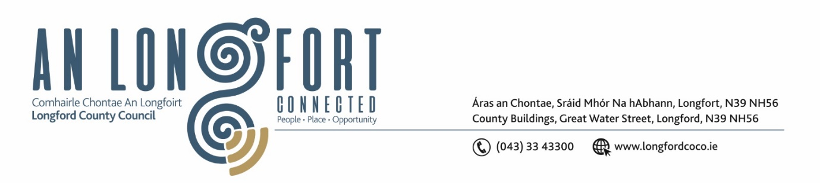

***Please note meeting will be held in the Council Chamber and via Microsoft Teams.***

17 June 2024

**Chuig: Gach Ball don Chomhairle**

A Chomhairleoir,

Iarrtar ort bheith i láthair ag Cruinniú Míosuil Chomhairle Chontae Longfoirt a tionólfar i Seomra na Comhairle, Aras an Chontae, Longford ar an 21 la **Aoine Meitheamh 2024 ag 3pm** chun gnó a dhéanamh d’réir an Chláir thíos.

You are requested to attend the Annual Meeting of Longford County Council to be held in the **Council Chamber** on **Friday 21 June at 3pm** to transact business, as set out on the Agenda hereunder.

**CLAR**

**1.** Return of persons elected to Longford County Council on the 7 June 2024.

**2**. Election of Cathaoirleach.

**3.** Election of Leas Cathaoirleach.

**4.** Declaration of Interest by Members.

**5**. Election of Nominees to the following Bodies and Committees

I. Appointment of 2 Members to the Eastern and Midland Regional Assembly

II. Appointment of Chairpersons to the four Strategic Policy Committees

III. Appointment of 4 Members to Longford Local Community Development Committee

IV. Appointment of 7 Members to Longford Local Community Safety Partnership – Steering Group

V. Appointment of 3 Members to Longford Sports Partnership

VI. Appointment of 3 Members to Association of Irish Local Government

VII. Appointment of 1 Member to Local Authority Members Association

VIII. Election of 4 Members to Longford and Westmeath Education Training Board

IX. Appointment of 3 Members to Regional Health Forum, Dublin Mid-Leinster

X. Appointment of Cathaoirleach or their nominee to Midlands Regional Transition Team

XI. Appointment of 1 Member to Midland Regional Drug and Alcohol Task Force

XII. Appointment of 1 Member to Midlands Energy Agency

XIII. Appointment of 1 Member to Irish Public Bodies Mutual Insurances Ltd

XIV. Appointment of 3 Members to County Longford Tourism Committee

XV. Appointment of 3 Members to Longford Pool Construction Ltd

XVI. Appointment of 3 Members to Longford Enterprise Development Company

XVII. Appointment of 2 Members for AGM and EGM and 1 Member as Director to

Backstage Theatre

XIX. Appointment of 2 Members to Longford County Council Audit Committee

XX. Appointment of Chairperson and 2 Members to Local Traveller Accommodation Consultative Committee

XXI. Appointment of 3 Members to County Rural Water Monitoring Committee

XXII. Appointment of 1 Member as Chairperson to Comhairle na nÓg Steering Committee

XXIII. Appointment of Members to Regeneration Committee

XXIV. Appointment of 3 Members to Creative Ireland Culture Team

XXV. Appointment of 3 Members to Heritage Forum

XXVI. Appointment of 3 Members to Biodiversity Working Group

XXVII. Appointment of 3 Members to County Business Incentive Scheme Committee

XXVIII. Appointment of 3 Members to Tender Committee

XXIX. Appointment of 3 Members to Place Naming Committee

XXX. Appointment of 3 Members Protocol and Procedures Committee

**6.** Introduction to Longford County Council – Workshop for Elected Members.

**7.** Consideration of Standing Orders.

**8.** Arrangements for Longford County Council Meetings and Municipal District Meetings.

Mise le meas,

Claire McNabola

***Claire McNabola***

***Meetings Administrator***